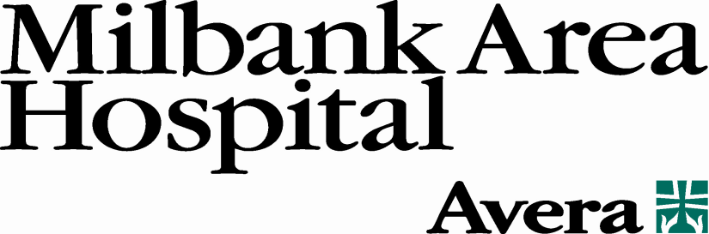

Health Care Education Scholarship

Eligibility requirements:
1. Applicant must be a Milbank High School Senior.
2. Applicant must be pursuing a career in health care.
The scholarship award will be $1,000.00.
Send completed application and letters of reference to:
Milbank High School
Attn: Ms. Heidi Lundborg
1001 E Park
Milbank, SD 57252
Selection:
A selection committee will review the applications and select the recipient.
Notification:
Notification will be made by the selection committee by letter to the recipient.
Deadline:
All applications must be submitted to Milbank High School by April 22nd.

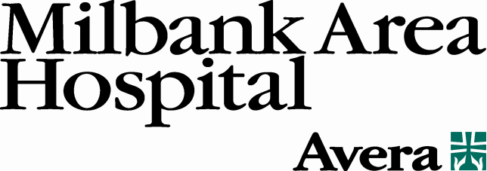

Health Care Education Scholarship
Application Form

Date of Application:______________________

Name:__________________________________________________________________

Address:________________________________________________________________

City:_________________________________ State:_______ Zip:_________________

Phone Number:_______________________ Cell (if applicable):__________________

College or University Name:_______________________________________________

Degree being sought:______________________________________________________

Please attach a separate typed sheet describing the following (500 words or less):

- Objectives and rationale for wanting to further your education in health care?

- What would you do to improve our current health care system?

Two letters of reference are needed in support of your application.

- __________________________________________________________________
Name Address
__________________________________________________________________
Phone Relationship to you

- __________________________________________________________________
Name Address
__________________________________________________________________
Phone Relationship to you

Please return completed applications to Ms. Heidi Lundborg at Milbank High School by April 22nd

